**BRAC UNIVERSITY**

B

**Department of Computer Science and Engineering**

**CSE420: Compiler Design**

**Quiz 01, Summer 2016**

**Duration: 1.00 hours, Total Marks: 30**

**Student Name:**

**Student ID:**

**Section:**

1. Mention some other applications of compiler design techniques. [2]

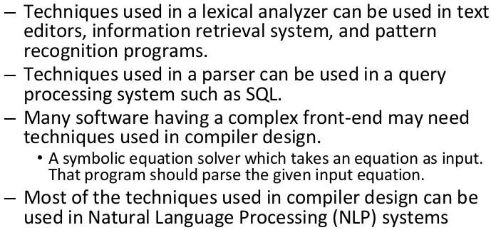

1. What factors have influenced the functional division of Lexical and Syntax Analyzer? [2]

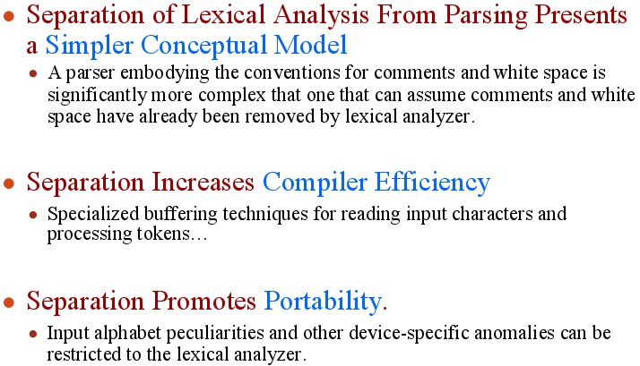

1. State the basic differences between NFA and DFA. [2]

|  |  |
| --- | --- |
| **NFA** | **DFA** |
| 1. NFA stands for non-deterministic finite automata. | 1. DFA stands for deterministic finite automata. |
| 2. NFA can reach multiple states for a single input. | 2. DFA can have only one transition for a single input. |
| 3.NFA can have epsilon transition. | 3.DFA cannot have epsilon transition |
| 4.NFA requires less space than DFA | 4.DFA requires more space than NFA |
| 5.NFA has larger simulation time. | 5.DFA has less simulation time than NFA. |

1. Convert RE (**a*b)|(bca)|(c|a)\*** to NFA using Thompson’s Construction. [6]

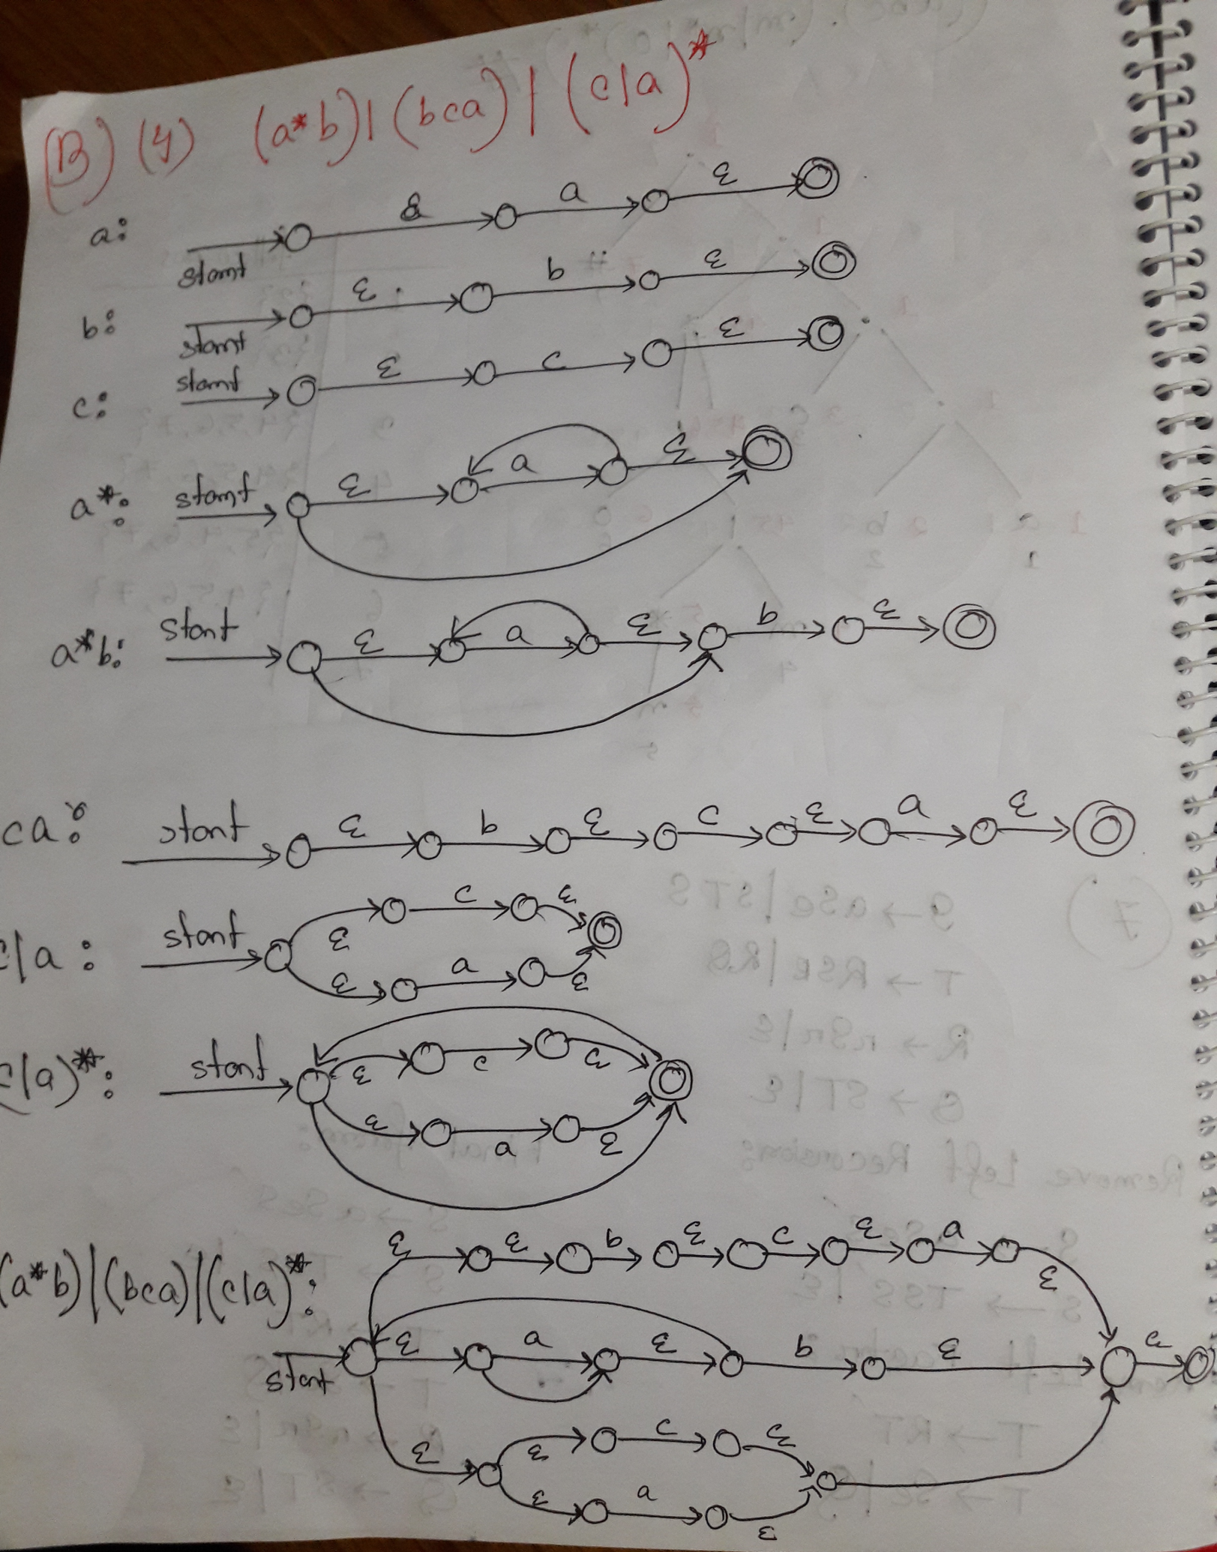

1. Convert following NFA to DFA using Subset Construction method. [3]

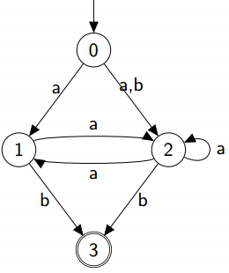

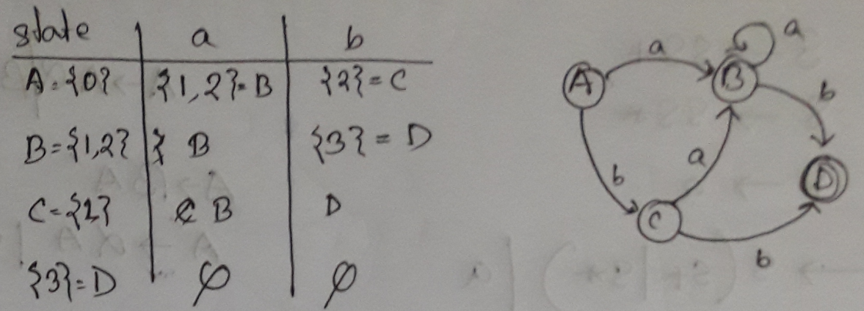

5. Convert following DFA to RE : [4]

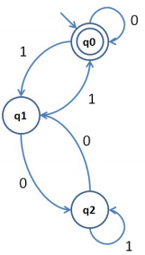

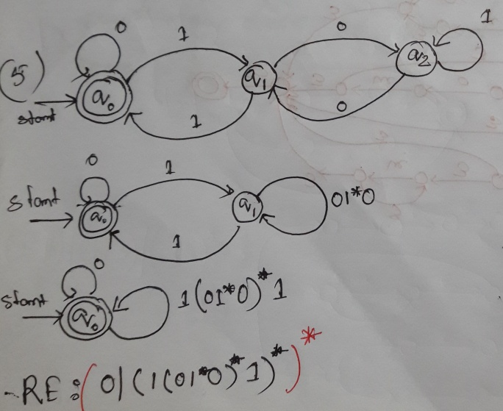

6. Draw the syntax tree of RE **(x.y.z).(m+n*+o)\*** and determine the first-pos, last-pos, follow-pos of each node. [2+1.5+1.5+3]

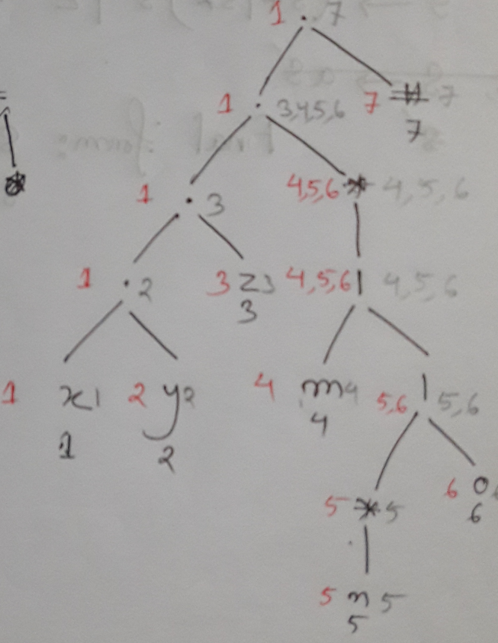

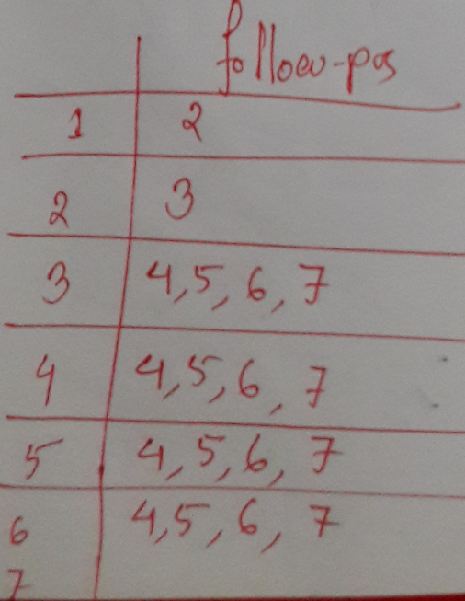

7. Remove ambiguities from the following grammar: [3]

 S-> SS+

 S-> SS*

 S-> a

